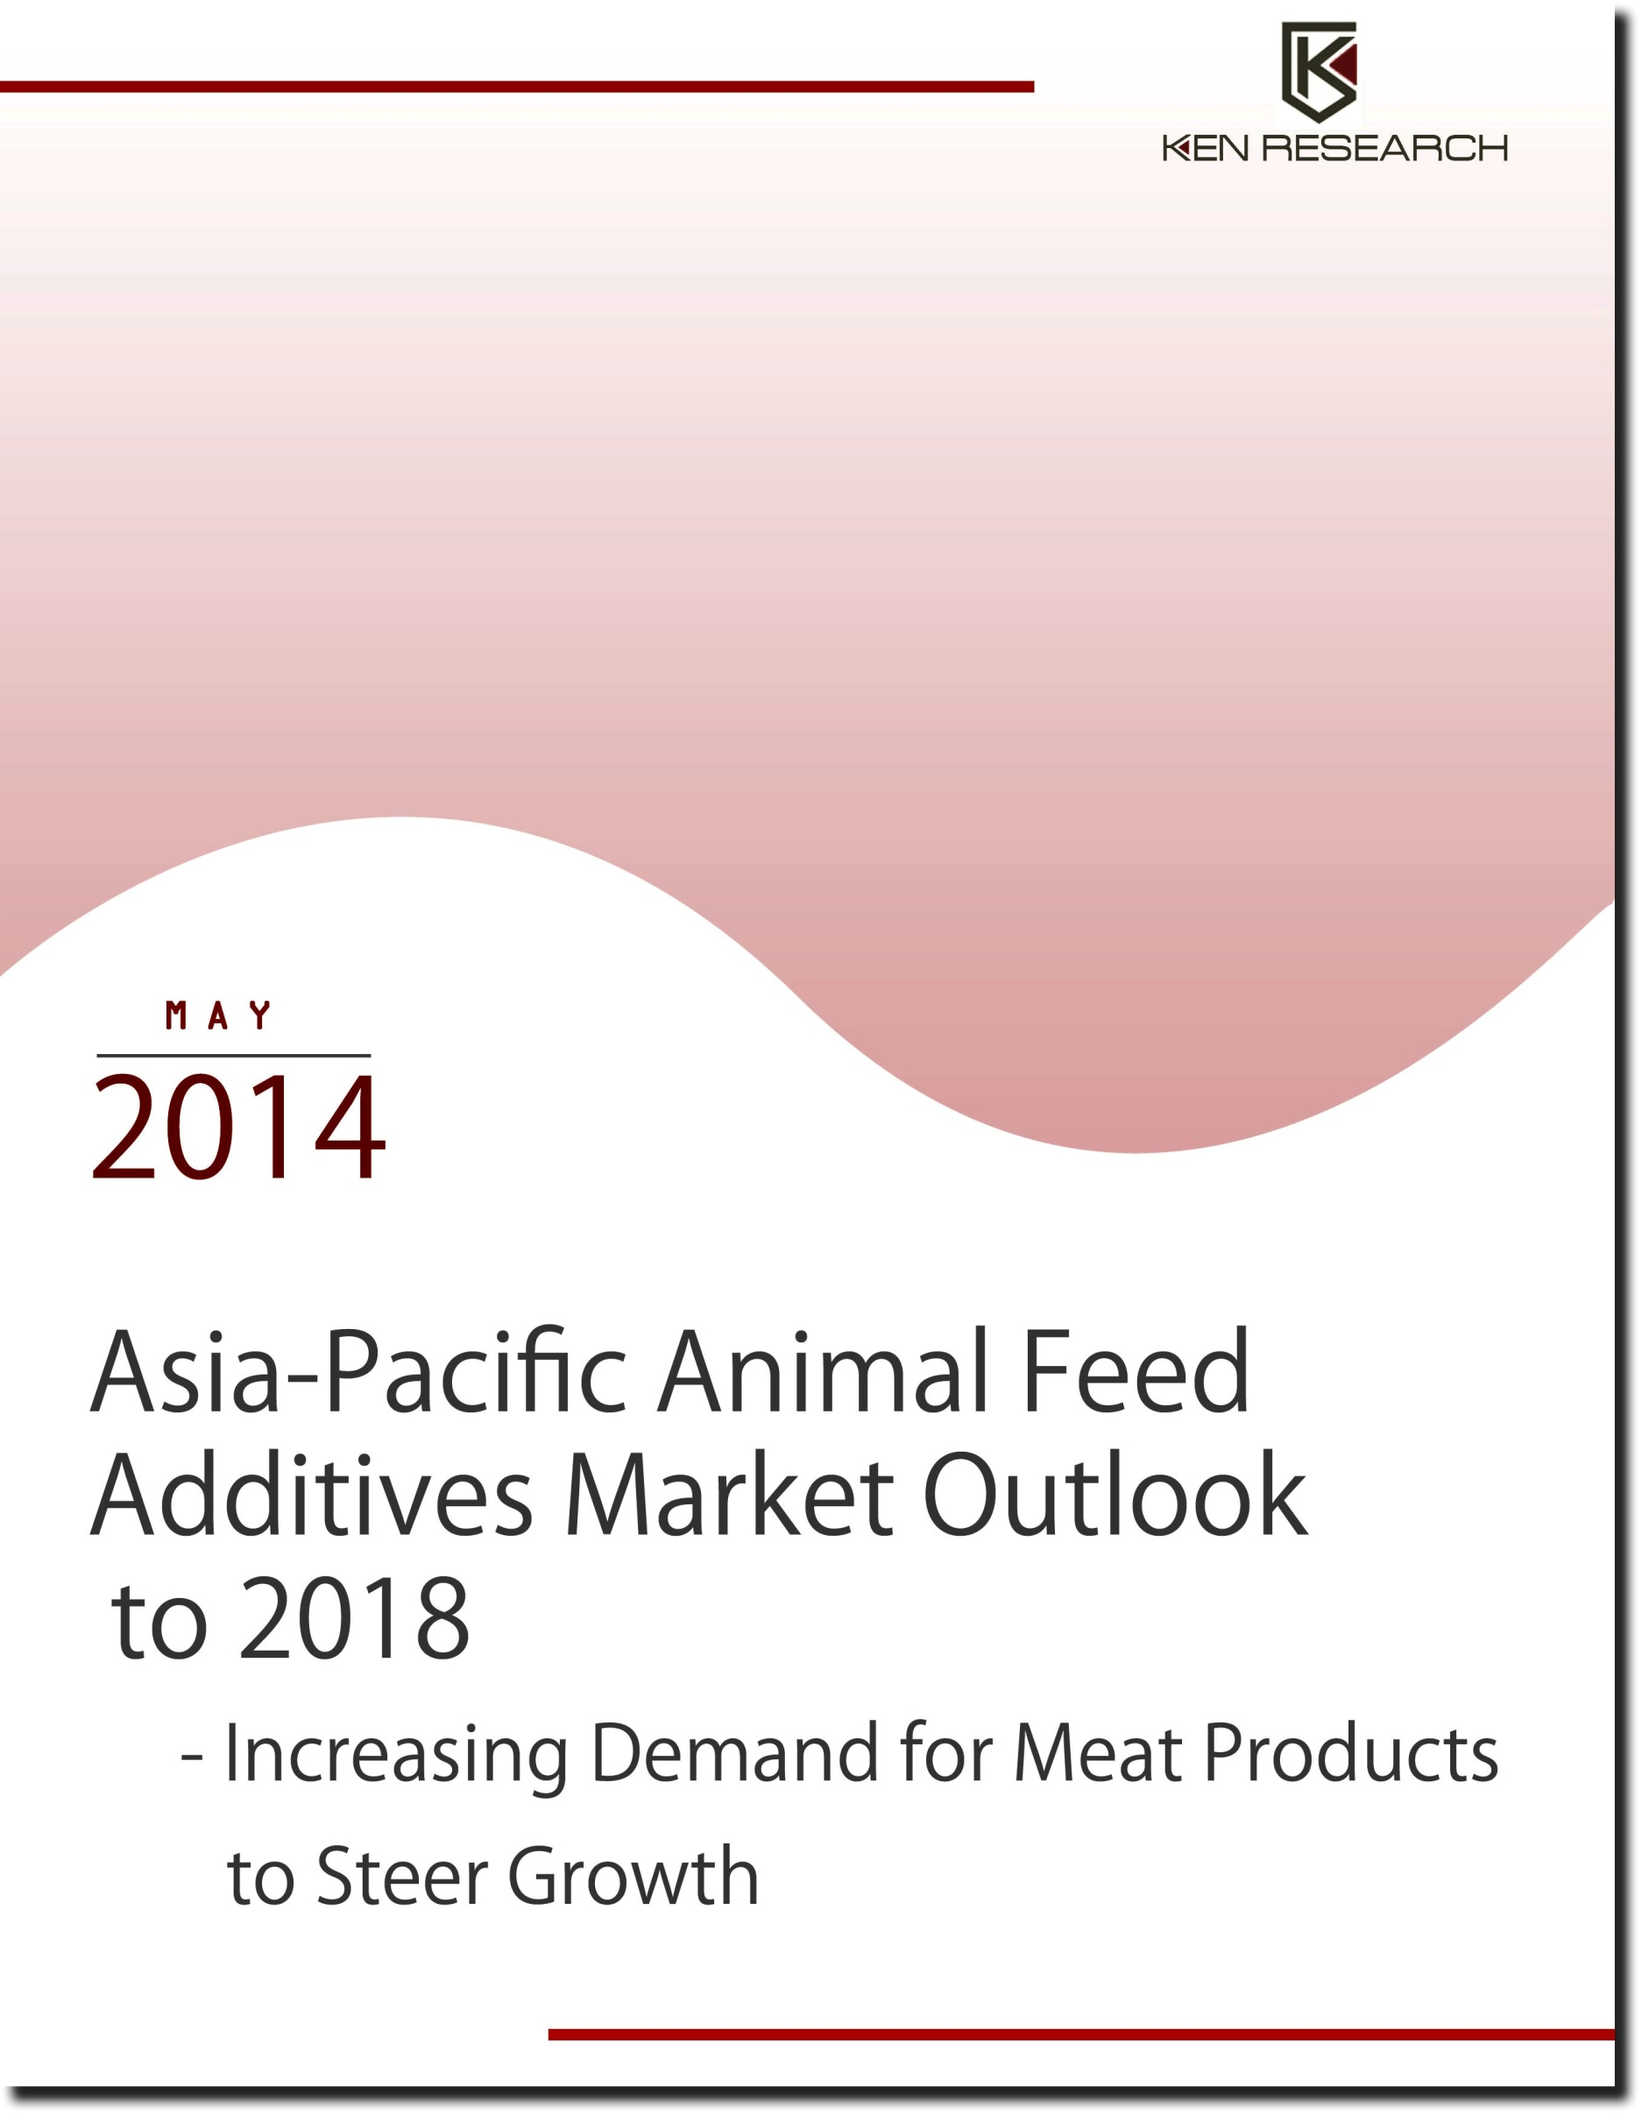

Table of Contents
1. Global and Asia Pacific Animal Feed Additives Market Introduction
Asia-Pacific Animal Feed Additives Market
2. Distribution and Supply Chain of Feed Additives
3. Asia-Pacific Animal Feed Additives Market Size by Revenue, 2007-2013
4. Asia-Pacific Animal Feed Additives Market Segmentation
4.1. By Geography, 2007-2013
5. Competitive Landscape of Major Players in Asia-Pacific Animal Feed Additives Market
6. Asia-Pacific Animal Feed Additives Market Future Outlook and Projections
6.1. Cause and Effect Relationship in Asia-Pacific Animal Feed Additives Market
6.2. Asia-Pacific Animal Feed Additives Market Future Outlook and Projections, 2014-2018.
7. China Animal Feed Additives Market
7.1. China Animal Feed Additives Introduction and Market Size by Revenue, 2007-2013
7.2. China Animal Feed Additives Market Segmentation
7.2.1. By Products (Di Calcium Phosphate, Lysine, Choline Chloride and others)
7.2.1.1. By Revenues, 2007-2018
Prices of Major Constituents of Animal Feed Additives in China
7.2.1.2. By Production, 2007-2018
7.2.2. By Livestock, 2013
7.3. China Animal Feed Additives Market Government Regulations
7.4. Trends and Developments in China Animal Feed Additives Market
Leading Global Producer of Animal Feed Grade Vitamin Additives
Pig Feed Dominating the Feed Additives Market
7.5. Market Share of Major Players in China Animal Feed Additives Market, 2013
7.6. Competitive Landscape of Major Players in China Animal Feed Additives Market
7.7. China Animal Feed Additives Market Future Outlook and Projections, 2014-2018
7.8. Macroeconomic Factors Affecting the China Animal Feed Additives Market
7.8.1. Output of Livestock Sector, 2007-2018
7.8.2. Animal Husbandry Gross Output, 2007-2018
7.8.3. Farmer’s per Capita Income in China, 2007-2018
7.8.4. China Compound Feed Production, 2007-2018
8. India Animal Feed Additives Market
8.1. India Animal Feed Additives Introduction and Market Size by Revenue, 2007-2013
8.2. India Animal Feed Additives Market Segmentation
8.2.1. By Products, 2007-2018
8.2.2. By Livestock, 2013
8.3. Imports and Exports of Animal Feed and Supplements Preparations, FY’2008-FY’2013
8.4. Government Rules and Regulations
8.5. Trends and Developments in India Animal Feed Additives Market
Meat Demand Driving the Feed Additive Industry
Poultry Dominating the Feed Additives Market
8.6. Market Share of Major Players in India Animal Feed Additives Market
8.6.1. Market Share of Major Players in India Poultry Animal Feed Additives Market, 2013
8.6.2. Market Share of Major Players in India Ruminant Feed Additives Market, 2013
8.7. Competitive Landscape of Major Players in India Animal Feed Additives Market
8.8. India Animal Feed Additives Market Future Outlook and Projections, 2014-2018
8.9. Macroeconomic Factors Affecting the India Animal Feed Additives Market
8.9.1. Output of Livestock Sector, 2007-2018
8.9.2. Livestock Population, 2007-2018
8.9.3. Meat production, 2007-2018
Analyst Recommendation
9. Appendix
9.1. Market Definitions
9.2. Abbreviations
9.3. Research Methodology
Data Collection Methods
Approach
Variables (Dependent and Independent)
Multi Factor Based Sensitivity Model
Final Conclusion
9.4. Disclaimer

List of Figures
Figure 1: Global Animal Feed Additives Market Segmentation by Geography on the Basis of Revenue Contribution in Percentage, 2013
Figure 2: Global Animal Feed Additives Market Segmentation by Products on the Basis of Revenue Contribution in Percentage, 2013
Figure 3: Asia-Pacific Animal Feed Additives Market Segmentation by Geography on the Basis of Growth Rate (CAGR) in Percentage, 2007-2013
Figure 4: Distribution and Supply Chain of Animal Feed Additives Market
Figure 5: Asia-Pacific Animal Feed Additives Market Size on the Basis of Revenue in USD Million, 2007-2013
Figure 6: Asia-Pacific Animal Feed Additives Market Future Projections on the Basis of Revenues in USD Million, 2014-2018
Figure 7: China Animal Feed Additives Market Size on the Basis of Revenues in USD Million, 2007-2013
Figure 8: China Animal Feed Additives Segmentation by Type of Livestock on the Basis of Revenue Contribution in Percentage, 2013
Figure 9: China Animal Feed Additives Market Future Projections on the Basis of Revenues in USD Million, 2014-2018
Figure 10: Output of Livestock Sector in China in Million Tons, 2007-2018
Figure 11: China Animal Husbandry Gross Output in USD Million, 2007-2018
Figure 12: Per Capita Income of Farmers in China, 2007-2018
Figure 13: China Compound Feed Production in Million Tons, 2007-2018
Figure 14: India Animal Feed Additives Market Size on the Basis of Revenue in USD Million, 2007-2013
Figure 15: India Animal Feed Additives Segmentation by Type of Livestock on the Basis of Revenues in Percentage, 2013
Figure 16: Market Share of Major Players in India Poultry Feed Additives Market on the Basis of Revenue in Percentage, 2013
Figure 17: Market Share of Major Players in India Ruminant Feed Additives Market on the Basis of Revenue Contribution in Percentage, 2013
Figure 18: India Animal Feed Additives Market Future Projections on the Basis of Revenue in USD Million, 2014-2018
Figure 19: Output of Livestock Sector in India in USD Million, 2007-2018
Figure 20: Livestock Population in India in Million, 2007-2018
Figure 21: India Meat Production in Million Tons, 2007-2018

List of Tables
Table 1: Asia-Pacific Livestock Population in Million, 2007-2010
Table 2: Asia-Pacific Animal Product Output in Million Tons, 2007-2010
Table 3: Per Capita Animal Production in Asia-Pacific in Kilograms/Year, 2007-2010
Table 4: Asia-Pacific Animal Feed Additives Market Segmentation by Geography on the Basis of Revenue Contribution in Percentage, 2007-2013
Table 5: Asia-Pacific Animal Feed Additives Market Segmentation by Geography on the Basis of Revenue Contribution in USD Million, 2007-2013
Table 6: Competitive Landscape of Major Players (Lonzain, BASF, Ajinomoto, CHR Hasen, Phibro Animal Health Corporation, Zoetis, Tessenderlo, DSM, Novozymes, Evonik) in Asia-Pacific Animal Feed Additives Market
Table 7: Cause and Effect Relationship Analysis between Industry Factors and Expected Animal Feed Industry Prospects in Asia-Pacific
Table 8: Asia-Pacific Animal Feed Additives Market Future Projections by Geography on the Basis of Revenue Contribution in Percentage, 2014-2018
Table 9: Asia-Pacific Animal Feed Additives Market Future Projections by Geography on the Basis of Revenue Contribution in USD Million, 2014-2018
Table 10: Overview of Major Feed Additives Manufactured, Location and Production Capacities of Major Players in China, 2010
Table 11: China Animal Feed Additives Market Segmentation by Products on the Basis of Revenue Contribution in Percentage, 2007-2013
Table 12: China Animal Feed Additives Market Segmentation by Products on the Basis of Revenue Contribution in USD Million, 2007-2013
Table 13: China Animal Feed Additives Market Future Projections by Products on the Basis of Revenue Contribution in Percentage, 2014-2018
Table 14: China Animal Feed Additives Market Future Projections by Products on the Basis of Revenue Contribution in USD Million, 2014-2018
Table 15: Average Lysine Prices in China (Lysine Content 98.5%) in RMB/Kg and USD/Kg, 2013
Table 16: Average Lysine Prices in China (Lysine Content 70.0%) in RMB/Kg and USD/Kg, 2013
Table 17: Average Lysine Prices (Lysine Content 65.0%) in RMB/Kg and USD/Kg, 2013
Table 18: Average Methionine Prices in China in RMB/Kg and USD/Kg, 2013
Table 19: Average Choline Chloride Prices in China in Yuan/MT and USD/MT, 2013
Table 20: China Animal Feed Additives Market Segmentation by Products on the Basis of Production in Percentage, 2007-2013
Table 21: China Animal Feed Additives Market Segmentation by Products on the Basis of Production in Thousand Tons, 2007-2013
Table 22: China Animal Feed Additives Market Future Projections by Products on the Basis of Production in Thousand Tons, 2014-2018
Table 23: Production Bases of Major International Firms in China, 2010
Table 24 China Animal Feed Additives Segmentation by Type of Livestock on the Basis of Revenue Contribution in USD Million, 2013
Table 25: China Animal Feed Additives Market Production by Livestock in Thousand Tons, 2008-2009
Table 26: Market Share of Major Players in China Animal Feed Additives Market on the Basis of Revenues in Percentage, 2013
Table 27: Competitive Landscape of Major Players in China Animal Feed Additives Market
Table 28: Operating Income of Major China Animal Feed Additives Players in USD Million, 2013
Table 29: Number of Veterinary Hospitals in India, FY’2012
Table 30: Number of Veterinary Dispensaries in India, FY’2012
Table 31: Foreign Direct Investment (FDI) Policy for Animal Husbandry in India, 2013
Table 32: Number of Veterinary Aid Centers in India, FY’2012
Table 33: India Animal Feed Additives Market Segmentation by Products on the Basis of Revenue Contribution in Percentage, 2007-2013
Table 34: India Animal Feed Additives Market Segmentation by Products on the Basis of Revenue Contribution in USD Million, 2007-2013
Table 35: India Animal Feed Additives Market Future Projections by Products on the Basis of Revenue Contribution in Percentage, 2014-2018
Table 36: India Animal Feed Additives Market Future Projections by Products on the Basis of Revenue Contribution in USD Million, 2014-2018
Table 37: India Animal Feed Additives Market Segmentation Types of Livestock on Basis of Revenue Contribution in USD Million, 2013
Table 38: Import of Different Mixes Used in Animal Feed in India in USD Million, FY’ 2008-FY’2013
Table 39: Export of Different Mixes Used in Animal Feed in India in USD Million, FY’2008- FY’2013
Table 40: Basic Duty on Different Types of Animal Nutrition Products in India, 2013
Table 41: Meat Production in India by Type of Livestock, 2009-2010
Table 42: Revenues of Major Players in India Poultry Feed Additives Market in USD Million, 2013
Table 43: Revenues of Major Players in India Ruminant Feed Additives Market in USD Million, 2013
Table 44: Competitive Landscape of Major Players in India Animal Feed Additives Market
Table 45: Import Value of Livestock and Livestock Products in India in USD Million, FY’2009- FY’2013
Table 46: Export Value of Livestock and Livestock Products in India in USD Million, FY’2009- FY’2013
Table 47: Correlation Matrix for China Animal Feed Additives Market
Table 48: Regression Coefficients Output

Executive Summary
The industry research publication titled ‘Asia-Pacific Animal Feed Additives Market Outlook to 2018 - Increasing Demand for Meat Products to Steer Growth’ presents a comprehensive analysis of market size by value of animal feed additives in Asia pacific. The report entails the market share analysis and company profiles of major players in the feed additives industry in major geographic markets including China and India. The future analysis and segmentation by geographies, products and livestock have also been discussed in each of the sub-segment.
Asia-Pacific animal feed additives market is the largest in the world comprising of almost one third of the global animal feed additive market. Improving nutrient availability, digestibility and growth rate of animals throughout Asia-Pacific and particularly in countries such as India, China, Vietnam and Australia have been some of the factors that have promoted to the growth of feed additives in the region. Additionally, consumption of feed additives has also been observed to play an important role in reducing environmental pollution associated with the livestock industry which has been another factor that has resulted in increased usage of the feed additives throughout Asia pacific.
Feed additives have shown a lot of potential to contribute to the development of livestock industry in Asia-Pacific region with revenues for Asian market reaching USD ~ million in 2013 at a CAGR of 8.3% in last six years. The largest contributor of the Asia-Pacific market was China with a contribution of 65.3% in 2013. China has been the largest producer of feed additives in Asia-Pacific region with three major products namely di-calcium phosphate, Lysine and Choline chloride, reaching a production volume of ~ thousand tons in 2013. The major type of feed additive products used throughout Asia-Pacific includes amino acids, enzymes, vitamins, acidifiers, non antibiotic growth promoters and others. While China has been the leading producer of feed additives such as vitamins, it still lacks the technology for hi tech products such as amino acids. Poultry and swine have been the two major segments accounting a significant proportion of the animal feed additives market owing to the rising meat demand from these segments.
The animal feed additives industry in Asia-Pacific would represent a favorable growth rate largely due to the surge in demand for animal products comprising of meat, eggs and milk. The long term development of animal feed additive industry would largely be driven by the socio economic megatrends helping the industry to grow at a rate of 8.8% during 2013-2018 to reach revenues of USD ~ million by 2018. China would continue to be the largest contributing segment of the Asia-Pacific animal feed additives market with its contribution reaching to ~% in 2018. As a result of growing world population, the demand for animal protein products would continue to showcase an upward trend.

Key Topics Covered in the Report
- The market size of the Asia-Pacific Animal Feed Additives market in terms of value
- Asia-Pacific animal feed additives market segmentation by geographies (India, China, Japan, Thailand, Vietnam and others)
- Future projections of Asia-Pacific animal feed additives market
- Competitive Landscape of major Players in animal feed additives market.
- Market Size, segmentation and future projections of China animal feed additives market
- Market Size, segmentation and future projections of India animal feed additives market
- Trends and Developments in China and India animal feed additives market
- Government Rules and Regulations in China and India animal feed additives market
- Competitive landscape of major players operating in China animal feed additives market
- Competitive landscape of major players operating in India animal feed additives market
- Future projections and macro economic factors of India and China animal feed additives market

