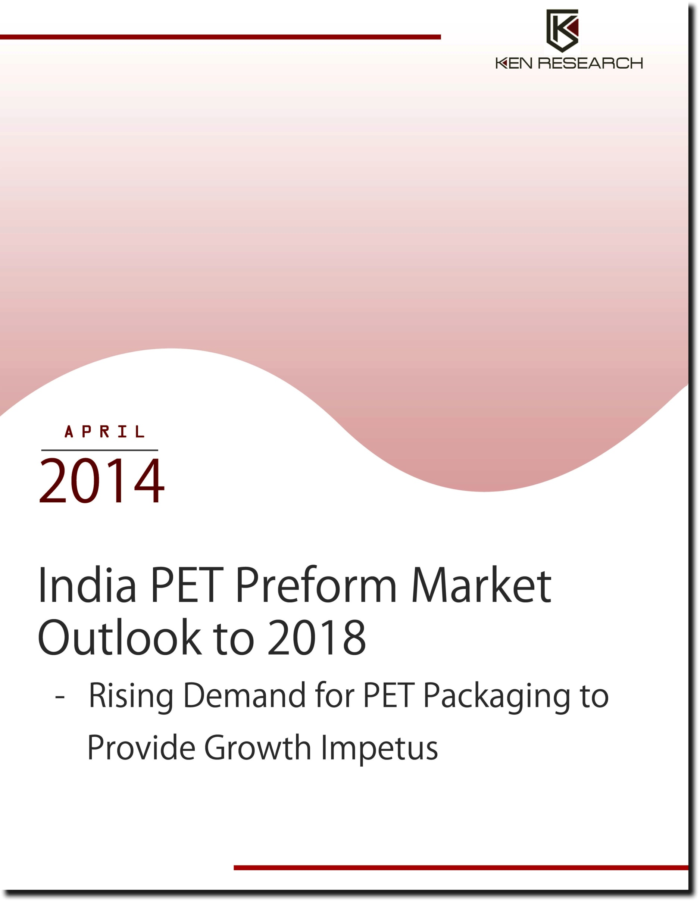

Table of Contents
1. India PET Preform Market Introduction
2. Value Chain Analysis of India PET Preforms Market
2.1. PET Preform Value Chain in India
2.2. Preforms in the PET Bottles Value Chain
3. India PET Preform Market Size, FY’2008-FY’2013
3.1. By Production Volume, FY’2008-FY’2013
3.2. By Turnover, FY’2008-FY’2013
4. India PET Preform Market Segmentation, FY’2008-FY’2013
4.1. By Application, FY’2008-FY’2013
4.2. By Organized and Unorganized, FY’2013
5. Pricing Scenario in India PET Preform Market
6. Export Import Scenario in India PET Preform Market
7. Required Investment for Establishing a PET Preforms Manufacturing Plant in India
8. Trends and Developments in India PET Preform Market
Continuous Capital Expenditure
Increasing Usage of Compression Technology
Conversion Price Model
9. Government Regulations and Certifications in India PET Preform Market
FDA compliances
European Regulations
Bureau of Indian Standards
Import Duty, Taxes and Import Restrictions
Small Scale Industries (SSI) Registration
10. Growth Drivers and Opportunities in India PET Preform Market
Low Per Capita Consumption of PET in India
Shift to PET Bottles from Glass Bottles
Growth of the Packaging Industry in India
Development of Retail Channels in India
Rising Demand for Bottled Water
11. Issues and Challenges in India PET Preform Market
High Initial Capital Investment
High Volatility in Raw Material Prices
Ban of PET Bottles for Pharmaceutical Packaging
Other Issues in India PET Preform Industry
12. Market Shares of Major Companies in India PET Preform Market, FY’2013
13. Competitive Scenario of Major Companies in India PET Preform Market
14. India PET Preform Market Future Outlook and Projections, FY’2014-FY’2018
14.1. By Production Volume, FY’2014-FY’2018
14.2. By Turnover, FY’2014-FY’2018
14.3. Cause and Effect Relationship in India PET Preform Market
15. Macroeconomic Factors in India PET Preform Market; Historical and Projected
15.1. Packaging Industry Market Size in India, FY’2008-FY’2018
15.2. Per Capita Consumption of PET (Polyethylene Terephthalate) in India, FY’2008-FY’2018
15.3. Polymers Production in India, FY’2008-FY’2018
15.4. PET Resin Demand in India, FY’2008-FY’2018
15.5. Personal Disposable Income in India, FY’2008-FY’2018
16. Appendix
16.1. Market Definitions
16.2. Abbreviations
16.3. Research Methodology
Data Collection Methods
Approach
Variables (Dependent and Independent)
Final Conclusion
16.4. Disclaimer

List of Figures
Figure 1: India PET Preform Market Value Chain
Figure 2: The Role of Preform in PET Bottle Value Chain
Figure 3: India PET Preform Market Size on the Basis of Production in Thousand Tons, FY’2008-FY’2013
Figure 4: India PET Preform Market Size on the Basis of Turnover in INR Million, FY’2008-FY’2013
Figure 5: India PET Preform Market Segmentation by End-user Application on the Basis of Production in Percentage (%), FY’2013
Figure 6: India PET Preform Market Segmentation by Organized and Unorganized Sector in Percentage (%), FY’2013
Figure 7: India Export and Import of PET Preforms in Thousand Tons, FY’2013-FY’2014
Figure 8: India Export and Import of PET Preforms in INR Million, FY’2013-FY’2014
Figure 9: India PET Preform Market Future Projections on the Basis of Production in Thousand Tons, FY’2014-FY’2018
Figure 10: India PET Preform Future Projections on the Basis of Turnover in INR Million, FY’2014-FY’2018
Figure 11: India Packaging Industry Market Size in INR Million, FY’2008-FY’2018
Figure 12: Per Capita Consumption of PET in India in Kilograms, FY’2008-FY’2018
Figure 13: Polymer Production in India in Million Tons, FY’2008-FY’2018
Figure 14: PET Resin Demand in India in Million Tons, FY’2008-FY’2018
Figure 15: Personal Disposable Income in India in INR Million, FY’2008-FY’2018

List of Tables
Table 1: Required Parameters for the Establishment of a PET Preforms’ Manufacturing Plant
Table 2: Cost Structure for the Establishment of a PET Preforms’ Manufacturing Plant
Table 3: Means of Finance for Establishing a PET Preforms’ Manufacturing Plant
Table 4: Financial Indicators Related to the Establishment of a PET Preforms’ Manufacturing Plant
Table 5: Market Share of Major Companies in India PET Preform Market on the Basis of Revenue in INR Million, FY’2013
Table 6: Competitive Landscape of Major Players in India PET Preform Market
Table 7: Clientele of Major Companies in India PET Preform Market
Table 8: Cause and Effect Relationship Analysis between Industry Factors and Expected PET Preform Market Prospects in India
Table 9: Correlation Matrix of India PET Preform Market
Table 10: Regression Coefficients Output

Executive Summary
The global plastics industry is observing a continuous shift of production bases to low-cost Asian countries. With increasing foreign investment and rise in the number of new manufacturing establishments in the region, Asia has become the largest and the fastest growing market for plastics in the world. In particular, China and India offer enormous growth opportunities due to expanding production activities in the countries. Growth in plastic industry in India was boosted after the economic liberalization in 1991. The subsequent deregulation and privatization resulted in resurgence in all the end-user sectors such as packaging, construction, telecom, automotive and white goods.
Packaging sector is the largest application sector for the plastic industry, representing almost 60.0% the total plastics demand in FY’2013. Estimated at ~ million tons in FY’2013, plastic consumption for packaging in India is expected to reach 10.0 million tons by 2020. The FMCG sector compiled with rise in capital investment pose as the key growth drivers for the packaging industry in the country. The consumer base for several commodities in India, especially FMCGs is expanding due to the rising disposable income of the population.
The demand for packaging of these products has lead to the development of the plastic packaging industry in the country. Among the vast family of plastics, Polyethylene Terephthalate, popularly known as PET, is expected to grow the fastest at 11.0% annually. Majority of the PET available in India is utilized in the production of bottles. In the recent years, PET bottles have inundated the Indian market, with annual growth rate in consumption exceeding 20.0%.
PET is constantly replacing conventional bottle raw materials such as glass and metal. Apart from being lightweight, PET offers several other advantages such as pack weight reduction, ease of handling and longer shelf life of packaged goods. Furthermore, PET bottles are persuasive in terms of sustainability, technical performance and aesthetics. PET packaging is increasingly being used in healthcare and personal care products, packaged foods and beverages markets. Advancements in packaging material science and mounting demand for product protection and stability are further driving demand for PET bottles in India.
The demand for preforms is directly driven by the consumption of PET bottles in India. The production of PET preforms in India in FY’2008 was estimated to be ~ thousand tons, which has been growing at 19.2% CAGR to reach ~ thousand tons in FY’2013. In terms of turnover, the preforms market in India in FY’2013 was INR ~ million and has been growing at 20.1% CAGR from INR ~ million in FY’2008. Preforms are manufactured for different end user applications, comprising segments such as carbonated soft drinks, packaged drinking water, alcoholic beverages and others.
The dominance of the organized and unorganized sector in the Indian PET preforms market varies in all end user applications of preforms. The major companies operating in the organized segment of the PET preform market in India are Manjushree Technopack Ltd., Sunrise Containers Ltd., Chemco Plastic Industries Ltd., National Polyplast (India) Ltd. and Parle Agro Pvt. Ltd. The PET preforms market in India is anticipated to grow substantially on account of the shifting preference from glass bottles to PET bottles, rising demand for consumer goods and packaged drinking water, and the development of retail channels in the country.

Key Topics Covered in the Report
- The market size of India PET preform industry in terms of production volume and turnover
- Market segmentation of the PET preforms market in India by end-user applications and organizational structure of the market
- Import and export scenario of PET preforms
- Required investment for establishing a pet preforms manufacturing plant in India
- Trends and developments in India PET preform market
- Government regulations and certifications in the Indian PET preform market
- Growth drivers and challenges in the PET preform market in India
- Market shares of major players in India PET preform market
- Competitive scenario of major companies in India PET preform market
- Future outlook and projections of PET preform market in India

