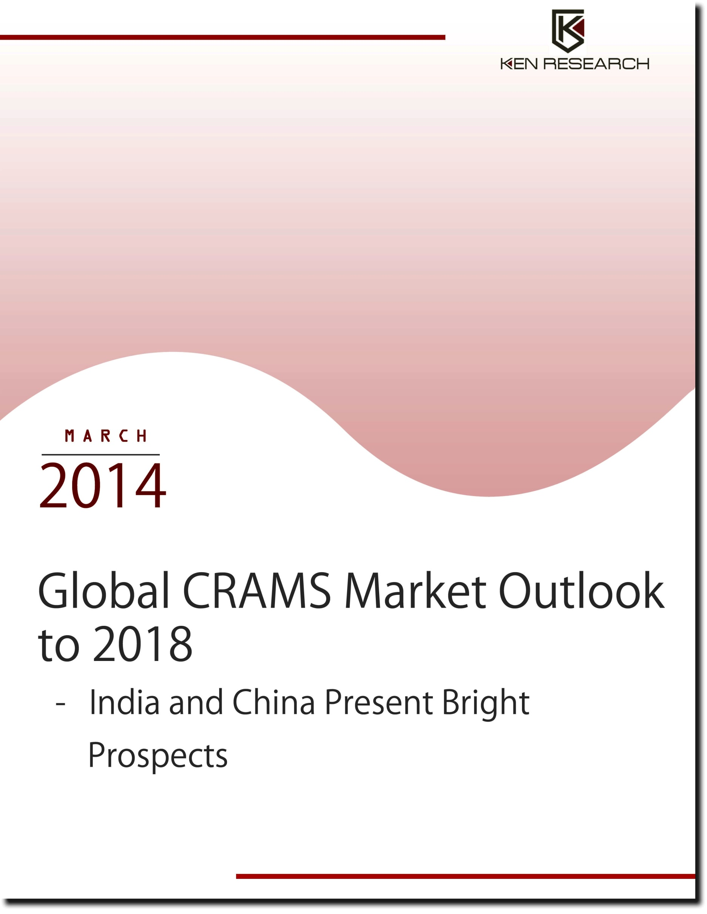

Table of Contents
List of Figures
List of Tables
1. Global CRAMS Market Introduction
2. Global CRAMS Market Production Chain
Stages of Drug Development
Business Models
3. Global CRAMS Market Size by Revenue, 2007-2013
4. Global CRAMS Market Segmentation
4.1. By Geography, 2007-2013
4.2. By CMO and CRO, 2007-2013
5. The US CRAMS Market Introduction and Size, 2007-2013
5.1. The US CRAMS Market Segmentation
5.1.1. By CMO and CRO Market, 2007-2018
5.1.2. By Drugs and Devices Markets, 2007-2018
5.1.2.1. The US CRAMS for Drugs Market Segmentation by Therapeutic Classes, 2007-2018
5.2. Market Share of Major Players in the US CRAMS Market, 2013
5.3. Competitive Landscape of Major Players in the US CRAMS Market
5.4. Government Regulations in the US CRAMS Market
5.5. Trends and Developments in the US CRAMS Market
Focus on Solid Dosage in Contract Manufacturing
Evolution of E-clinical trials
Expiration of Patented Drugs
Privatization of CROs
Strategic Alliances between Pharmaceutical Companies and CROs
Reduced Government Spending on Clinical Research
5.6. The US CRAMS Market Future Outlook and Projections
5.7. Macro Economic Factors Affecting the US CRAMS Market
5.7.1. Ageing Population, 2007-2018
5.7.2. The US Health Expenditure, 2007-2018
5.7.3. Gross Domestic Product, 2007-2018
5.7.4. The US Pharmaceutical Companies Domestic R&D Expenditure, 2007-2018
5.7.5. Personal Disposable Income, 2007-2018
6. Germany CRAMS Market Introduction and Size, 2007-2013
6.1. Germany CRAMS Market Segmentation
6.1.1. By CMO and CRO Market, 2007-2018
6.1.2. By Drugs and Devices Market, 2007-2018
6.1.2.1. Germany CRAMS for Drugs Market Segmentation by Therapeutic Classes, 2007-2018
6.2. Market Share of Major Players in Germany CRAMS Market, 2013
6.3. Competitive Landscape of Major Players in Germany CRAMS Market
6.4. Government Regulations in Germany CRAMS Market
6.5. Trends and Developments in Germany CRAMS Market
Collaboration Schemes to Promote Innovation in CRAMS industry
6.6. Germany CRAMS Market Future Outlook and Projections, 2014-2018
6.7. Macro Economic Factors Affecting Germany CRAMS Market
6.7.1. Ageing Population (55 Years and Above), 2007-2018
6.7.2. Total Healthcare Expenditure, 2007-2018
6.7.3. Gross Domestic Product of Germany, 2007-2018
6.7.4. Pharmaceutical Industry Spending on Drug Development and Research, 2007-2018
6.7.5. Personal Disposable Income per Household, 2007-2018
7. India CRAMS Market Introduction and Size, 2007-2013
7.1. India CRAMS Market Segmentation
7.1.1. By CMO and CRO, 2007-2018
7.1.2. India CRAMS Market Segmentation by Drugs and Devices, 2007-2018
7.1.2.1. India CRAMS for Drugs Market Segmentation by Therapeutic Classes, 2007-2018
7.2. Market Share of Major Players in India CRAMS Market, 2011-2013
7.3. Company Profiles of Major Players in India CRAMS Market
7.3.1. Jubilant Life Sciences
7.3.1.1. Business Overview
7.3.1.2. Financial Performance, 2012 and 2013
7.3.1.3. Business Strategies
Focus on Inorganic Expansion
7.3.2. Divis Laboratories
7.3.2.1. Business Overview
7.3.2.2. Financial Performance, 2010-2013
7.3.2.3. Business Strategies
Increased Focus on Custom Synthesis
Focus on Establishing New Capacities
7.3.3. Biocon
7.3.3.1. Business Overview
7.3.3.2. Financial Performance, 2010 – 2013
7.3.3.3. Business Strategies
Focus on Collaborative Research and Development
Focus on Insulin Strategy
7.3.4. Dishman Pharmaceuticals
7.3.4.1. Business Overview
7.3.4.2. Financial Performance, 2010-2013
7.3.4.3. Business Strategies
Focus on Mid Sized Contracts
7.3.5. Dr Reddy’s Laboratories (Aurigene)
7.3.5.1. Business Overview
7.3.5.2. Financial Performance, 2012 and 2013
7.3.5.3. Business Strategy
Focus on Collaboration for Drug Discovery and Development
7.4. SWOT Analysis of India CRAMS Market
7.5. Government Regulations in India CRAMS Market
7.6. Trends and Development in India CRAMS Market
Greater Focus on Contract Manufacturing
Collaboration with Foreign Players
Shift from Non-Core Functions to Core Functions for Outsourcing
7.7. India CRAMS Market Future Outlook and Projections, 2014-2018
7.8. Macro-Economic Factors Affecting India CRAMS Market
7.8.1. Ageing Population (55 Years and Above), 2007-2018
7.8.2. Total Healthcare Expenditure, 2007-2018
7.8.3. Gross Domestic Product, 2007-2018
7.8.4. India Pharmaceutical Industry Revenues, 2007-2018
7.8.5. Personal Disposable Income, 2007-2018
8. China CRAMS Market Introduction and Size, 2007-2013
8.1. China CRAMS Market Segmentation
8.1.1. By CMO and CRO, 2007-2018
8.1.2. By Drugs and Devices Market, 2007-2018
8.1.3. China CRAMS for Drugs Market Segmentation by Therapeutic Classes, 2007-2018
8.2. Competitive Landscape of Major Players in China CRAMS Market
8.3. Government Regulations in China CRAMS Market
8.4. Trends and Developments in China CRAMS Industry
Focus on API and Bulk Drug Manufacturing
Rising Clinical Trial Activities
8.5. China CRAMS Market Future Outlook and Projections, 2014-2018
8.6. Macroeconomic Factors Affecting China CRAMS Market
8.6.1. Ageing Population (55 Years and Above), 2007-2018
8.6.2. Total Healthcare Expenditure, 2007-2018
8.6.3. Gross Domestic Product of China, 2007-2018
8.6.4. Expenditure on Drug Development, 2007-2018
8.6.5. Personal Disposable Income per Household, 2007-2018
9. Market Share of Major Players in Global CRAMS Market, 2011-2013
10. Global CRAMS Market Future Outlook and Projections, 2014-2018
10.1. Cause and Effect Relationship Analysis of Global CRAMS Industry
11. Appendix
11.1. Market Definitions
11.2. Abbreviations
11.3. Research Methodology
Data Collection Methods
Approach
Variables (Dependent and Independent)
Multi Factor Based Sensitivity Model
Final Conclusion
11.4. Disclaimer

List of Figures

Figure 1: CRAMS Market Production Chain
Figure 2: Global CRAMS Market Size on the Basis of Revenue in USD Billion, 2007-2013
Figure 3: Global CRAMS Market Segmentation by CMO and CRO on the Basis of Revenue Contribution in Percentage, 2007-2013
Figure 4: The US CRAMS Market Size on the Basis of Revenue in USD Billion, 2007-2013
Figure 5: The US CRAMS Market Segmentation by CMO and CRO on the Basis of Revenue Contribution in Percentage, 2007-2013
Figure 6: The US CRAMS Market Segmentation by Drugs and Devices on the Basis of Revenue Contribution in Percentage, 2007-2013
Figure 7: The US CRAMS Market Future Projections on the Basis of Revenue in USD Billion, 2014-2018
Figure 8: Aged Population in the US in Million, 2007-2018
Figure 9: The US Healthcare Expenditure in USD Billion, 2007-2018
Figure 10: Gross Domestic Product of GDP in the USD Billion, 2007-2018
Figure 11: R&D Expenditure of Pharmaceutical Companies in the US in USD Billion, 2007-2018
Figure 12: Personal Disposable Income in the US in USD Billion, 2007-2018
Figure 13: Germany CRAMS Market Size on the Basis of Revenue in USD Billion, 2007-2013
Figure 14: Germany CRAMS Market Segmentation by CMO and CRO on the Basis of Revenue Contribution in Percentage, 2007-2013
Figure 15: Germany CRAMS Market Segmentation by Drugs and Devices on the Basis of Revenue Contribution in Percentage, 2007-2013
Figure 16: Germany CRAMS Market Future Projections on the Basis of Revenue in USD Billion, 2014-2018
Figure 17: Aged Population in Germany in Million, 2007-2018
Figure 18: Germany Healthcare Expenditure in USD Billion, 2007-2018
Figure 19: Gross Domestic Product of Germany in USD Billion, 2007-2018
Figure 20: Pharmaceutical Industry Spending on Drug development and Research in USD Billion, 2007-2018
Figure 21: Germany per Capita Disposable Income in USD Thousands, 2007-2018
Figure 22: India CRAMS Market Size on the Basis of Revenue in USD Billion, 2007-2013
Figure 23: India CRAMS Market Segmentation by CMO and CRO on the Basis of Revenue Contribution in Percentage, 2007-2013
Figure 24: India CRAMS Market Segmentation by Drugs and Devices on the Basis of Revenue Contribution in Percentage, 2007-2013
Figure 25: India CRAMS Market Future Projections on the Basis of Revenue in USD Billion, 2014-2018
Figure 26: Aged Population in India in Million, 2007-2018
Figure 27: India Healthcare Expenditure in USD Billion, 2007-2018
Figure 28: Gross Domestic Product of GDP in USD Billion, 2007-2018
Figure 29: India Pharmaceutical Industry Market Size on the Basis of Revenues in USD Billion, 2007-2018
Figure 30: Personal Disposable Income of India in USD Billion, 2007-2018
Figure 31: China CRAMS Market Size on the Basis of Revenue in USD Billion, 2007-2013
Figure 32: China CRAMS Market Segmentation by CMO and CRO on the Basis of Revenue Contribution in Percentage, 2007-2013
Figure 33: China CRAMS Market Segmentation by Drugs and Devices on the Basis of Revenue in Percentage, 2007-2013
Figure 34: China CRAMS Market Future Projections on the Basis of Revenue in USD Billion, 2014-2018
Figure 35: Aged Population in China in Million, 2007-2018
Figure 36: China Healthcare Expenditure in USD Billion, 2007-2018
Figure 37: Gross Domestic Product of China in USD Billion, 2007-2018
Figure 38: Pharmaceutical Industry Spending on Drug Development in USD Billion, 2007-2018
Figure 39: China per Capita Disposable Income in USD Thousands, 2007-2018
Figure 40: Global CRAMS Market Future Projections on the Basis of Revenue in USD Billion, 2014-2018

List of Tables

Table 1: Global CRAMS Market Segmentation by Region on the Basis of Revenue in Percentage, 2007-2013
Table 2: Global CMO and CRO Market Size on the Basis of Revenue in USD Billion, 2007-2013
Table 3: The US CMO and CRO Market Size on the Basis of Revenue in USD Billion, 2007-2013
Table 4: The US CRAMS Market Segmentation by CMO and CRO on the Basis of Revenue Contribution in Percentage, 2014-2018
Table 5: The US CMO and CRO Market Future Projections on the Basis of Revenue in USD Billion, 2014-2018
Table 6: The US CRAMS Market Segmentation by Drugs and Devices on the Basis of Revenue in USD Million
Table 7: The US CRAMS Market Segmentation by Drugs and Devices on the Basis of Revenue Contribution in Percentage, 2014-2018
Table 8: The US Drugs and Devices CRAMS Market Future Projections on the Basis of Revenue in USD Billion, 2014-2018
Table 9: The US CRAMS for Drugs Market Segmentation by Therapeutic Areas on the Basis of Revenue Contribution in USD Billion, 2007-2013
Table 10: The US CRAMS for Drugs Market Segmentation by Therapeutic Areas on the Basis of Revenue Contribution in Percentage, 2007-2013
Table 11: The US CRAMS for Drugs Market Segmentation on the Basis of Revenue in Percentage, 2014-2018
Table 12: The US CRAMS for Drugs Market Future Projection on the Basis of Revenue in USD Billion, 2014-2018
Table 13: Number of Clinical Studies Performed in Different Therapeutic Areas in the US, 2007-2013
Table 14: Market Share of Major Players in the US CRAMS Market on the Basis of Revenue Contribution in Percentage, 2011-2013
Table 15: Revenue of Major Players in the US CRAMS Market in USD Million, 2011-2013
Table 16: Company Profiles of Major Players in the US CRAMS Market
Table 17: The US FDA Acts and Codes Governing the Drug Development Market
Table 18: List of Major Drugs Losing Patents in the US, 2013-2016
Table 19: The Major CROs in the US which were Privatized, 2011-2013
Table 20: Strategic Alliances between Pharmaceutical Companies and CROs in the US, 2012
Table 21: The US Fiscal Budgets and Funding to NIH, FY’2006- FY’2012
Table 22: Germany CMO and CRO Market Size on the Basis of Revenue in USD Billion, 2007-2013
Table 23: Germany CRAMS Market Segmentation by CMO and CRO on the Basis of Revenue Contribution in Percentage, 2014-2018
Table 24: Germany CMO and CRO Market Future Projections on the Basis of Revenue in USD Billion, 2014-2018
Table 25: Germany CRAMS Market Segmentation by Drugs and Devices on the Basis of Revenue in USD Million
Table 26: Germany CRAMS Market Segmentation by Drugs and Devices on the Basis of Revenue Contribution in Percentage, 2014-2018
Table 27: Germany Drugs and Devices Market Future Projections on the Basis of Revenue in USD Billion, 2014-2018
Table 28: Germany CRAMS for Drugs Market Segmentation by Therapeutic Areas on the Basis of Revenue Contribution in Percentage, 2007-2013
Table 29: Germany CRAMS for Drugs Market Segmentation by Therapeutic Areas on the Basis of Revenue in USD Million, 2007-2013
Table 30: Germany CRAMS for Drugs Market Segmentation on the Basis of Revenue Contribution in Percentage, 2014-2018
Table 31: Germany CRAMS for Drugs Market Future Projection on the Basis of Revenue in USD Million, 2014-2018
Table 32: Number of Clinical Studies Performed in Different Therapeutic Areas in Germany, 2007-2013
Table 33: Market Share of Major Players in Germany CRAMS Market on the Basis of Revenue in Percentage, 2011-2013
Table 34: Revenue of Major Players in Germany CRAMS Market in USD Million, 2011-2013
Table 35: Company Profiles of Major Players in Germany CRAMS Market
Table 36: Major Acquisitions in Germany CRAMS Market in USD Million
Table 37: Benefits, Risks and Challenges Faced by India CRAMS Industry
Table 38: India CMO and CRO Market Size on the Basis of Revenue in USD Billion, 2007-2013
Table 39: India CMO and CRO Market Future Projections on the Basis of Revenue in USD Billion, 2014-2018
Table 40: India CRAMS Market Segmentation by CMO and CRO on the Basis of Revenue Contribution in Percentage, 2014-2018
Table 41: Advantages of Setting up CROs in India
Table 42: India CRAMS Market Segmentation by Drugs and Devices on the Basis of Revenue in USD Billion, 2007-2013
Table 43: India CRAMS Market Segmentation by Drugs and Devices on the Basis of Revenue Contribution in Percentage, 2014-2018
Table 44: India Crams Market Segmentation by Drugs and Devices and Future Projections on the Basis of Revenue in USD Billion, 2014-2018
Table 45: India CRAMS for Drugs Market Segmentation by Therapeutic Areas on the Basis of Revenue Contribution in Percentage, 2007-2013
Table 46: India CRAMS for Drugs Market Segmentation by Therapeutic Areas on the Basis of Revenue in USD Million, 2007-2013
Table 47: India CRAMS for Drugs Market Segmentation on the Basis of Revenue Contribution in Percentage, 2014-2018
Table 48: India CRAMS for Drugs Market Future Projection on the Basis of Revenue in USD Million, 2014-2018
Table 49: Number of Clinical Studies Performed in Different Therapeutic Areas in India in Numbers, 2007-2013
Table 50: Market Share of Major Players in India CRAMS Market on the Basis of Revenue in Percentage, 2011-2013
Table 51: Revenue of Major Players in India CRAMS Market in USD Million, 2011-2013
Table 52: Recent Deals in India CMO Market
Table 53: Jubilant Life Science Service Revenues in USD Million and INR Million, 2012 and 2013
Table 54: Acquisition and Expansion Profile, FY’2003 - FY’2009
Table 55: Divis Laboratories CRAMS Revenue in USD Million and INR Million, 2009 – 2013
Table 56: Biocon CRAMS Revenue in USD Billion and INR Million, 2010 – 2013
Table 57: Dishman Pharmaceutical CRAMS Revenue in USD Million and INR Million, 2010-2013
Table 58: Aurigene Revenue in USD Million and INR Million, 2012 and 2013
Table 59: Investments by Major Pharmaceutical MNCs in China
Table 60: China CMO and CRO Market Size on the Basis of Revenue in USD Billion, 2007-2013
Table 61: China CRAMS Market Segmentation by CMO and CRO on the Basis of Revenue Contribution in Percentage, 2014-2018
Table 62: China CMO and CRO Market Future Projections on the Basis of Revenue in USD Billion, 2014-2018
Table 63: Acquisitions in China CRAMS Market, 2007-2010
Table 64: China CRAMS Market Segmentation by Drugs and Devices on the Basis of Revenue in USD Million, 2007-2013
Table 65: China CRAMS Market Segmentation by Drugs and Devices on the Basis of Revenue Contribution in Percentage, 2014-2018
Table 66: China CRAMS Market Segmentation Drugs and Devices Market Future Projections on the Basis of Revenue in USD Million, 2014-2018
Table 67: China CRAMS for Drugs Market Segmentation by Therapeutic Areas on the Basis of Revenue Contribution in Percentage, 2007-2013
Table 68: China CRAMS for Drugs Market Segmentation by Therapeutic Areas on the Basis of Revenue in USD Million, 2007-2013
Table 69: China CRAMS for Drugs Market Segmentation on the Basis of Revenue Contribution in Percentage, 2014-2018
Table 70: China CRAMS for Drugs Market Future Projection on the Basis of Revenue in USD Million, 2014-2018
Table 71: Number of Clinical Studies Performed in Different Therapeutic Areas in China, 2007-2013
Table 72: Competitive Landscape of Major Players in China CRAMS Market
Table 73: Revenue of Major Players in China CRAMS Market in USD Million, 2010-2013
Table 74: Clinical Trials Carried by Leading Players in China, 2010
Table 75: Market Share of Major Players in Global CRAMS Market, 2010-2013
Table 76: Revenues of Major Players in Global CRAMS Market in USD Million, 2010-2013
Table 77: Global CRAMS Market Segmentation by Countries on the Basis of Revenue Contribution in USD Billion, 2014-2018
Table 78: Cause and Effect Relationship Analysis between Industry Factors and Expected Prospects in the Global CRAMS Industry
Table 79: Correlation Matrix for India CRAMS Market
Table 80: Regression Coefficients Output

Executive Summary
The industry research publication titled ‘Global CRAMS Market Outlook to 2018 – India and China Present Bright Prospects’ presents a comprehensive analysis of market size by value of CRAMS services in globally. The report entails the market share analysis and company profiles of major players in the CRAMS industry. The future analysis and segmentation by geographies, drugs and devices and therapeutic areas have also been discussed in each of the sub-segment.
The past few years have been highly turbulent for the pharmaceutical industries particularly in the North American and European economies, with the operations being severely mitigated by a patent cliff and economic recession occurring at the same time. The resulting turmoil significantly changed the structure of global CRAMS industry with countries such as India and China assuming greater importance in the recent years. The increasing need for effective and safe drug discovery and manufacturing has been driving the revenues of global CRAMS industry, which reached USD ~ billion in 2013 representing a CAGR of 13.1% during 2007-2013. The US has been the largest contributor in the global CRAMS industry with a contribution of 39.8% in 2013 declining from 45.6% in 2007. The fall in its contribution was due to rising contribution of India and China which reached 5.4% and 4.0% respectively in 2013. Globally the contract manufacturing services accounted for ~% of the global CRAMS industry in 2013, growing at a CAGR of 12.0% during 2007-2013. The global CRAMS industry is highly fragmented with the top 13 players contributing only about ~% in the overall revenues of the industry in 2013. The major players of the global CRAMS industry include Quintiles, Boehringer Ingelheim, Covance, Parexel, PPD, Catalent and others.
The global CRAMS industry is expected to grow substantially in the coming years, achieving a market size of USD ~ billion in value terms by 2018. The growth would be supported by factors such as increased government spending on the healthcare sector in developing nations, increased competition in the pharmaceutical industry and increasing efficiency, availability and flexibility of outsourcing at lower cost. The industry would continue to witness a shift of the outsourcing activities from the Western countries to the emerging countries. For instance India’s share in the global CRAMS industry is anticipated reach 8.3% in 2018 from 5.4% in 2013. Growth in the global CRAMS industry would be driven by contract research services.

Key Topics Covered in the Report
- The market size of the global CRAMS market in terms of value in the last years (2007 - 2013)
- Global CRAMS market segmentation by geographies (The US, India, Germany, China and Rest of the World)
- Global CRAMS market segmentation by CMO and CRO
- Market Size, segmentation and future projections of India CRAMS industry
- Market Size, segmentation and future projections of China CRAMS industry
- Market Size, segmentation and future projections of the US CRAMS industry
- Market Size, segmentation and future projections of Germany CRAMS industry
- Trends and Developments in the US, Germany, India and China CRAMS market
- Government Rules and Regulations in the US, Germany, India and China CRAMS market
- Competitive landscape players operating in CRAMS globally (such as Quintiles, Covance, Parexel, PPD, Catalent, Lonza and others)
- Competitive landscape players operating in CRAMS market of the US, China, India and Germany
- Future projections and macro economic factors of India, China, Germany and US CRAMS market
- Future projections and macro economic factors of global CRAMS market.

